# ProBox Case 7681 & 8701 Assessment

## Custom Fields

* Next Invoice Date (New) - custbody_nextinv_new
* Rental Period (New) – custbody_rentperiod_new

## Current Monthly Billing Scheduled Script

* Name: ProBox : Billing w/ Auto-Pay
* Link: [Script](https://system.na1.netsuite.com/app/common/scripting/script.nl?id=99)
* Status: Scheduled, 9:30am then again every two hours

### Script Search Criteria

* 28 Day Billing Cycle
  + Type is Sales Order
  + Main Line is T
  + custbody_salecontract is F
  + custbody_billingfrequency is 28 Days
  + custbody_offrent is not on or before Today
  + custbody_lastinvoicedate is on or before (Today – 28 Days)
* Monthly
  + Type is Sales Order
  + Main Line is T
  + custbody_salecontract is F
  + custbody_billingfrequency is Monthly
  + custbody_offrent is not on or before Today
  + custbody_original_invoice_date is
    - if Today is the end of the Month then “greater than or equal to” today’s day of the month
    - if Today is not the end of the Month then “equal to” today’s day or the month
    - ***NOTE***: this was added as per Case 7147 (sub-note: script-comments say 7144) and was intended to resolve the Monthly billing issue. It might be worthwhile to see why this isn’t working.
* Deferred
  + Type is Sales Order
  + Main Line is T
  + custbody_salecontract is F
  + custbody_deferredbilling is on or before Today
  + custbody_lastinvoice is empty
  + custbody_deferredbillingapproval is T

### Script Changes to Implement

* Remove the Monthly-billing Internal ID from the loop of billing options

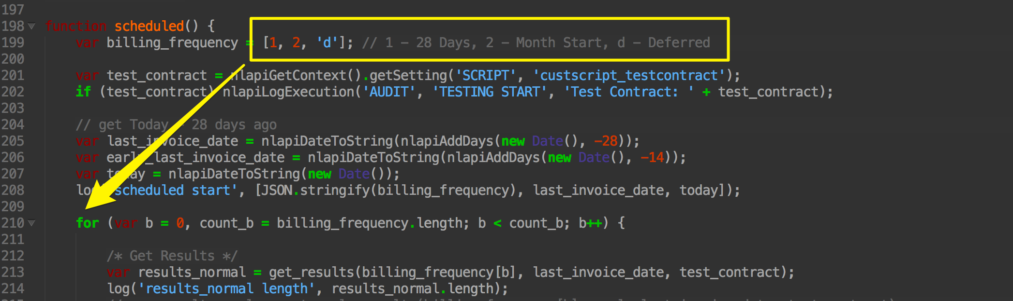

## Monthly Billing Script created to resolve Case 7681

* Name: ProBox : Billing w/ Auto-Pay – Adv Bill
* Link: [Script](https://system.na1.netsuite.com/app/common/scripting/script.nl?id=168)
* Status: Scheduled, 6:00pm

### Script Search Criteria (Primary Lookup)

This is run every time the scheduled script executes

* Type is Sales Order
* Main line is T
* custbody_salecontract is F
* custbody_billingfrequency is Monthly
* custbody_offrent is not on or before Today
* custbody_lastinvoicedate is on the same date as Today, last Month

### Script Search Criteria (Secondary Lookup)

This is only run in cases where today is the end of the Month

* Type is Sales Order
* Main line is T
* custbody_salecontract is F
* custbody_billingfrequency is Monthly
* custbody_offrent is not on or before Today
* custbody_lastinvoicedate is within (Today’s date plus one day, Last Month) and the end of Last Month

### Script Changes to Implement

Primary change would be to remove the test-contracts that are forcing the search to target these records via their Internal IDs.

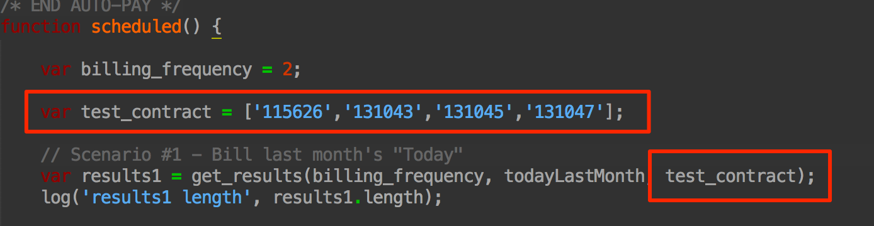

### Issues with Script’s current implementation

There are two critical issues (and a potential third) with the current script’s implementation, see below. I’ve created a Saved Search of the test-contracts, [link here](https://system.na1.netsuite.com/app/common/search/searchresults.nl?searchid=662), which I believe demonstrates that neither of the two use-cases below were actually tested (or at least tested in the entirety of this process).

* 1 - the script always assumes that it should be looking for contracts in the previous Month but the *year* of the Previous month always assumes it is *this year*. This means that it will never pick up a contract that’s started in a year that recurs into the next year
  + Solution: take the approach that Luke implemented in the current script (Case #7147). The field that should be added to the Sales Order is an integer field that should simply store the *day of the Month* the contract is first billed. This new field, being an integer, divorces the logic from having to take years into account
* 2 – the script, in looking at the custbody_lastinvoicedate field, means that it will corrupt the “original invoice date” value in cases where the original Invoice date is on a 30 or 31 day month.
  + For example: a Sales Order might be invoiced for the first time on 1/31/2016, the recurring Invoice for February would need to be on 2/29/2016, this would cause the custbody_lastinvoicedate field to be updated to reflect 2/29/2016. When *March’s* recurring bill is generated it *should* be generated on 3/30/2016, but this code would cause it to recur on 3/29/2016. Effectively all Sales Orders that exist for a year would end up being billed on the 28th over time as February would incorrectly remove the original Invoice date.
  + Solution: Same solution as #2 would allow for this to be resolved as we would transition away from the custbody_lastinvoicedate field when performing the Monthly billing logic
* 3 – This is a potential issue, it might be OK as the moment.js library is being loaded but my basic understanding is that a variable titled, “lastMonthDateObj”, is never initialized. This is also a variable that’s key to the entire logic driving the last-month comparisons.

